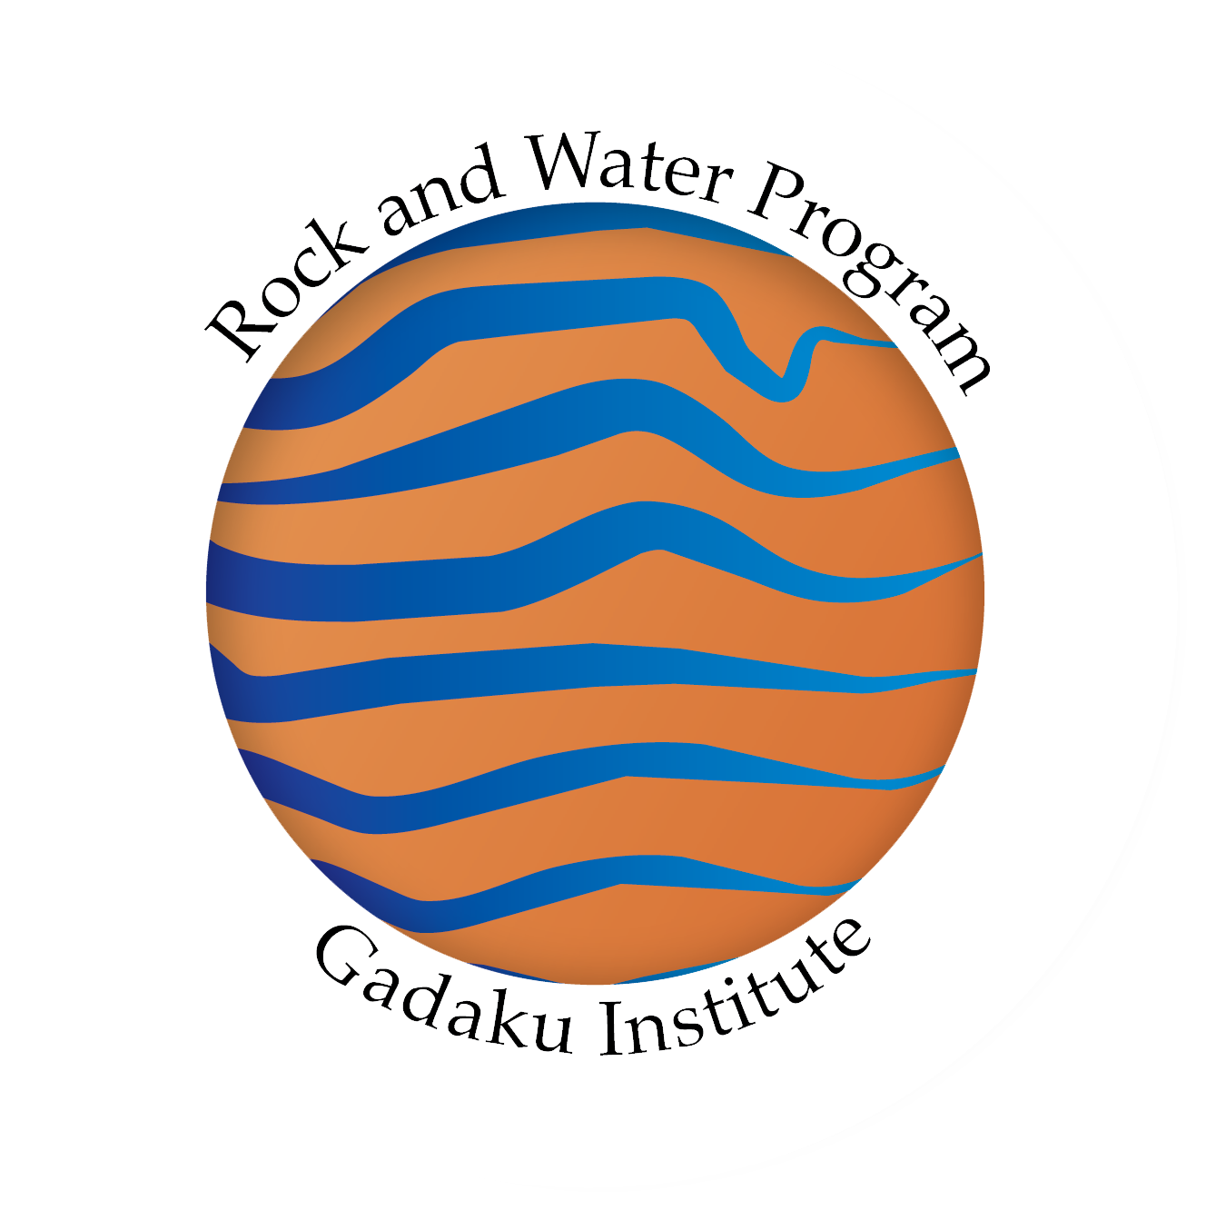
Rock and Water Ltd - Course Registration Form
21st-23rd October 2020
West Midlands, UK

Address for Correspondence:

Title (i.e. Mr, Ms, Dr):
Participant First Name:
Participant Surname:
Email:
Telephone:
Special dietary requirements:
Any disabilities or impairments:
Have you attended a Rock and Water training before?
Organisation & Job Role(if applicable)
Address Line 1:
Address Line 2:
City and Postcode
Country
Finance Contact Person:(if different)
Email:(if different from participant)

Course Fee: £675. Fee includes the new Course Manual, USB with videos, hot lunch + refreshments each day.

Method of payment: Upon receipt of the registration form, an invoice will be emailed to the planned participant or Finance Contact described above with details for completing the payment process. For your place to be confirmed, full payment must be received. Once full payment has been received, confirmation of your place will be sent via email. If you have not received confirmation, then you are not yet registered to attend the course.

Course Cancellation Policy:
Written requests to cancel a registration must be posted or emailed to us with the charges as follows:
4 weeks before course date: 25% of the full course fee
2 weeks before course date: 50% of the full course fee
Cancellations received less than 14 days before the course date will not be refunded although the registration can be transferred to another participant for the same course by written/email confirmation.
No refunds are given for non-attendance.

Whilst every effort is made to avoid changes to our training, we reserve the right to withdraw any course. If for any reason Rock and Water Ltd cancels a course, all course fees will be returned in full. We cannot however reimburse the cost of any pre-booked travel/accommodation arrangements and suggest that you might like to consider travel insurance to cover any significant costs incurred.

Disclaimer:
I hereby acknowledge the fact that the Rock and Water training course contains physical activities. I acknowledge the fact that I am taking part on the basis of my own free will and that I cannot hold Rock and Water Ltd and Gadaku Institute and its presenter responsible for any injury which may occur during the Rock and Water course. During the course, I myself will be responsible for all my actions and can always decide whether I will or will not participate in any specific exercises.

Note: It is the participant’s responsibility to advise Rock and Water Ltd and the presenter, of any pre-existing health issues prior to commencement of the first activity.

Please return this registration form to: Scott Neely, email: scott@rockandwater.org.uk

Privacy Statement:
Rock and Water Ltd takes your privacy seriously and will only use the information provided to administer your booking on our training course. We will not share your information with any third parties.

